**3. Docker Architecture or Docker**

**Docker architecture**

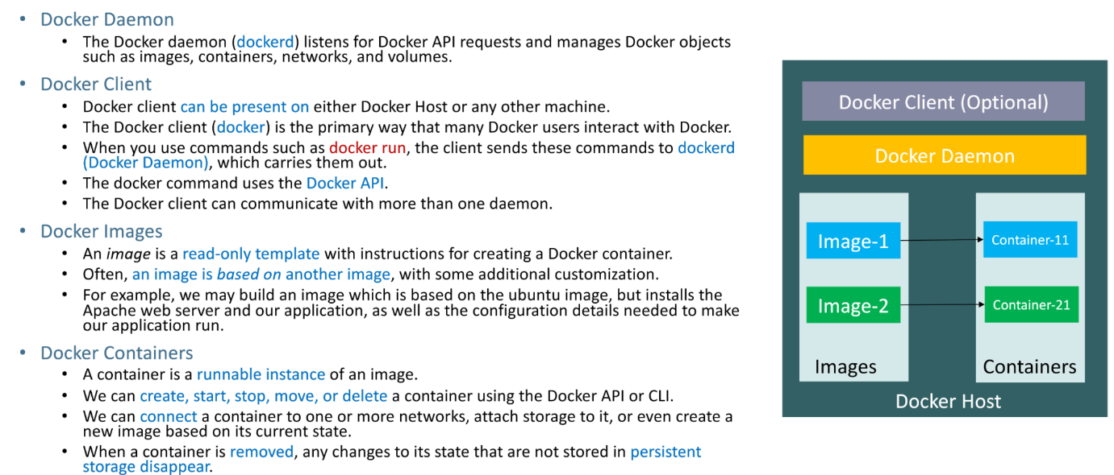

**Docker Terminology**

